**Developer Guide for Handling Data in Belleville Dental Hospital Website**

* **Introduction**
* The Technologies used in this Project
* **HTML5 (Hypertext Markup Language 5)**
* **CSS (Cascading Style Sheets)**
* **Bootstrap**
* **JavaScript**
* **jQuery**
* **AngularJS**
* **XML (extensible Markup Language)**
* **Meta tags:**

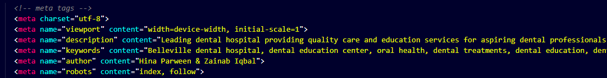

* **Social Media Tags:**

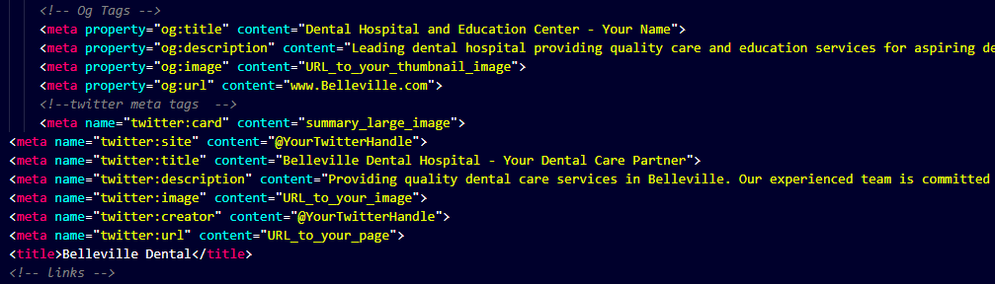

* **Linked with CDN (content delivery network)**
* **Font awesome**
* **Bootstrap Css**
* **Splider Css**
* **Animated css**
* **Favicon**
* **Custom css**
* **Responsive links**

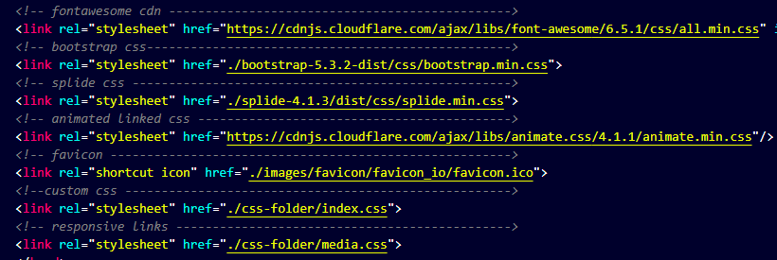

1. **Navigation**

* Logo and visitor counter
* Easy to read HTML code with commented.
* Html for responsive navigation menu

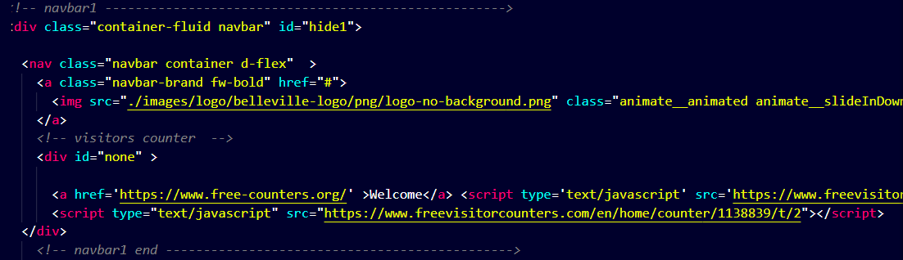

**2.Navigation with Nav Links**

* **Home**
* **Gallery**
* **Professional Education**
* **Patient Education**
* **Research**
* **Products**
* **About Us**
* **Contact Us**
* **Queries Link**

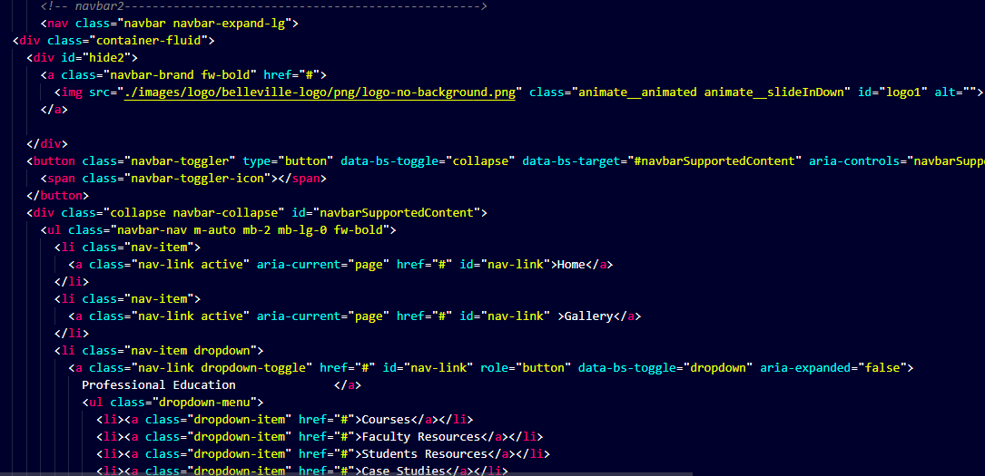

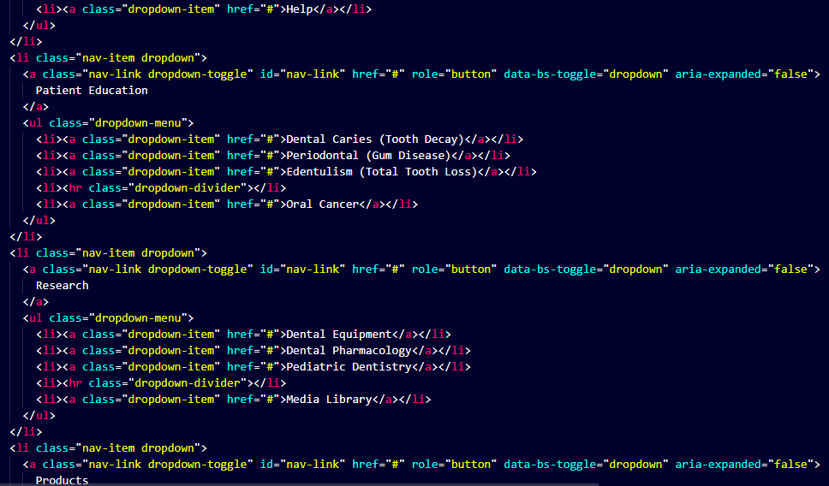

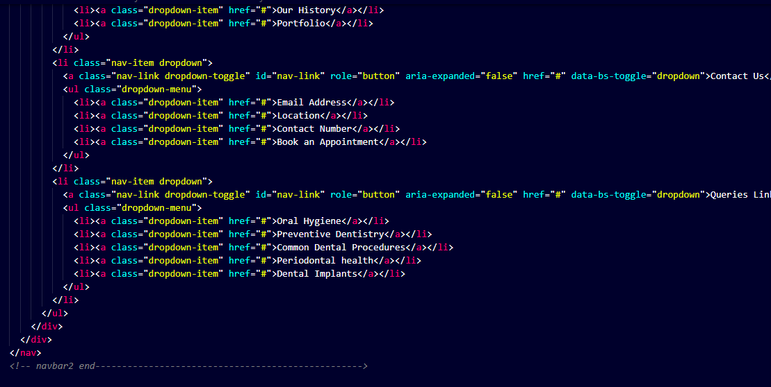

* **Slider HTML**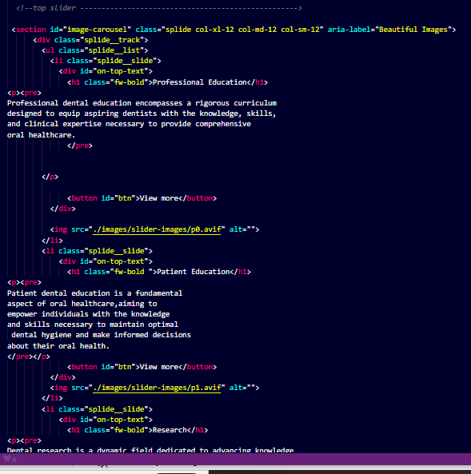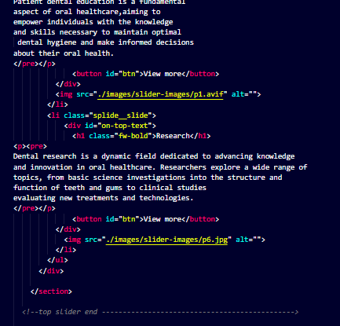
* **Slider CSS**

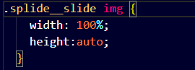

* 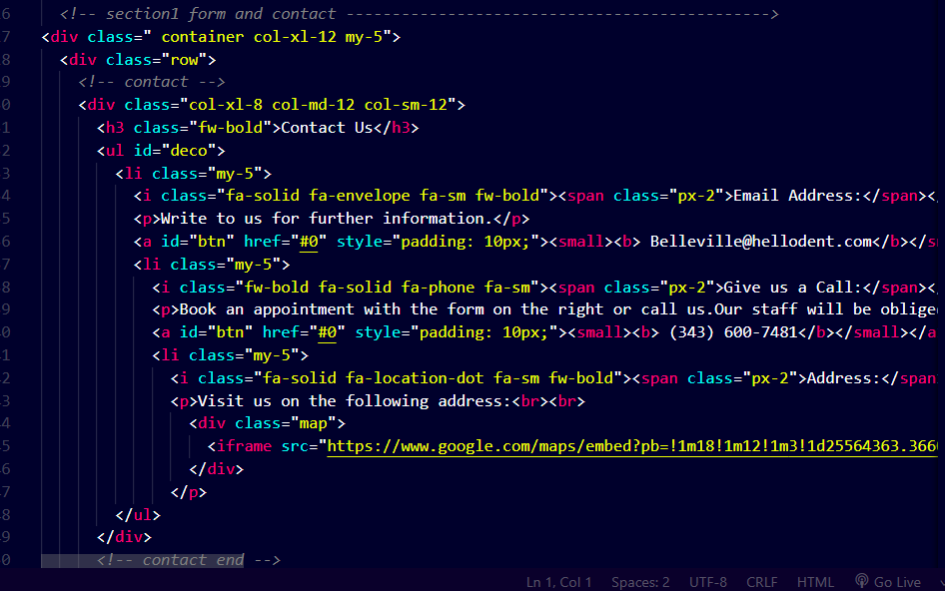**Contact Us & Appointment form HTML**

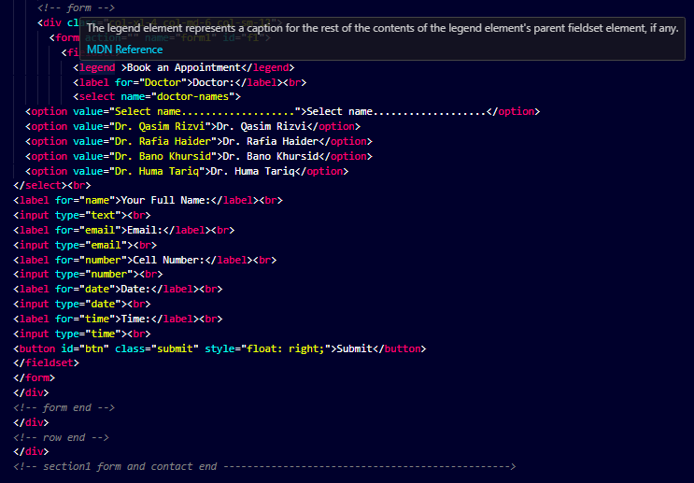

* **Contact Us & Appointment form CSS**

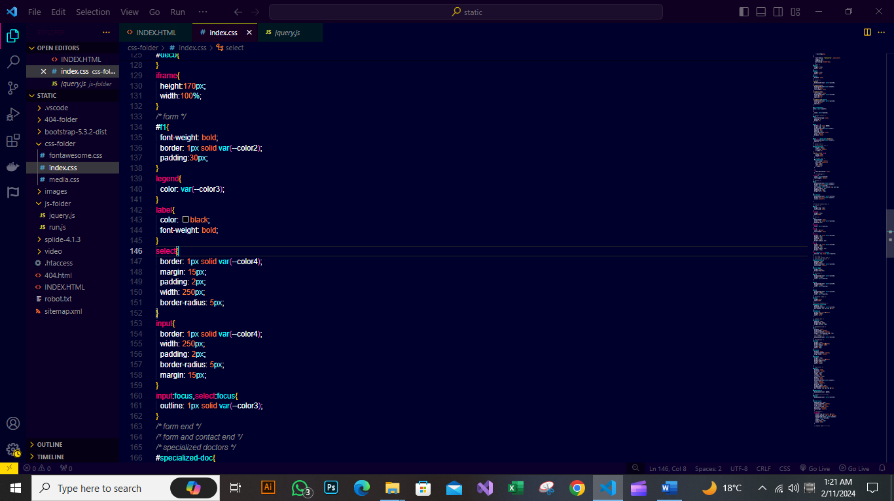

* 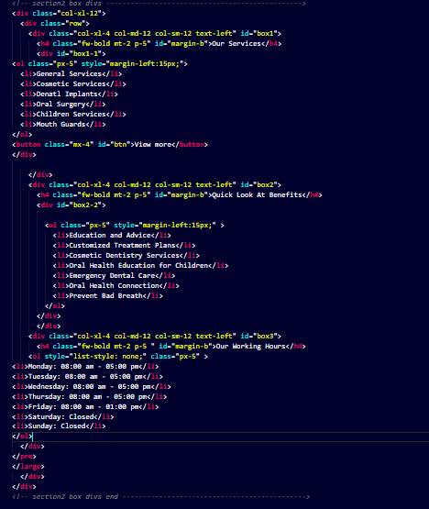**Service Cards HTML**

* 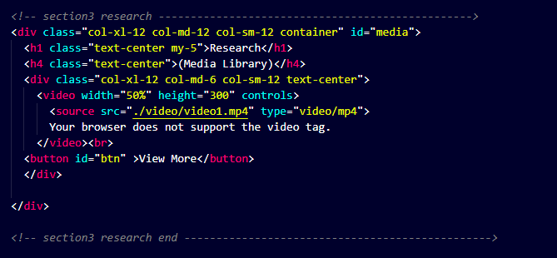**Research Video HTML**
* 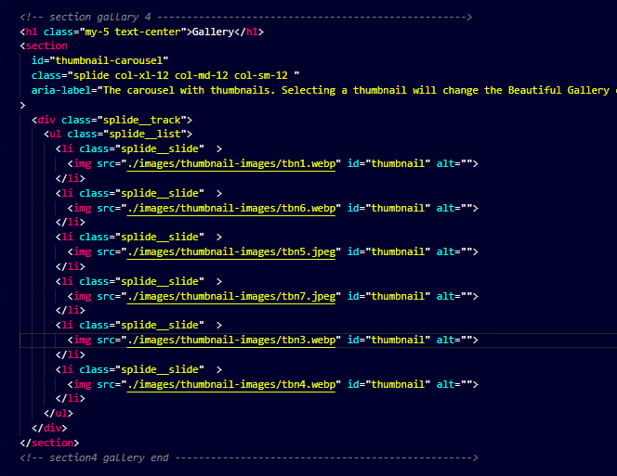**Gallery HTML**
* 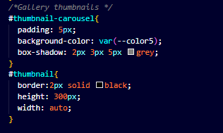**Gallery CSS**
* **Our Specialized Doctors HTML**

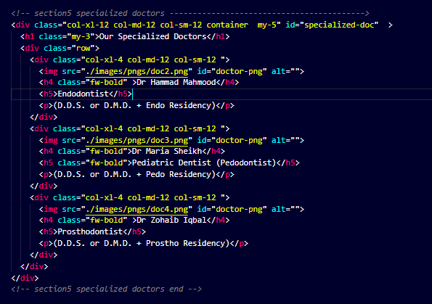

* **Our Specialized Doctors CSS**

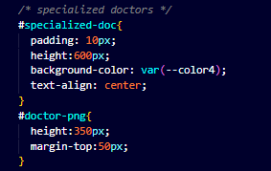

* 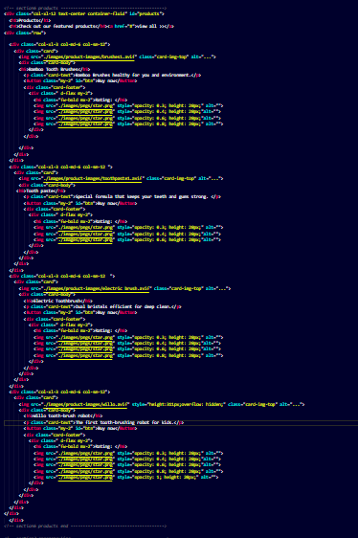**Products HTML**
* **Products CSS**

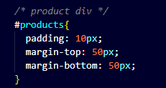

* 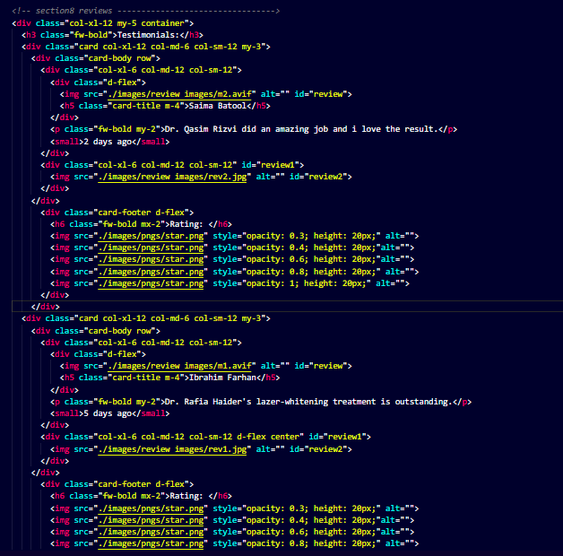**Testimonial HTML**
* **Testimonial CSS**

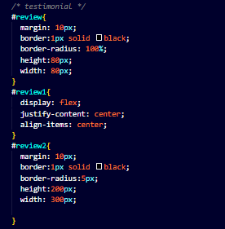

* **Footer HTML**

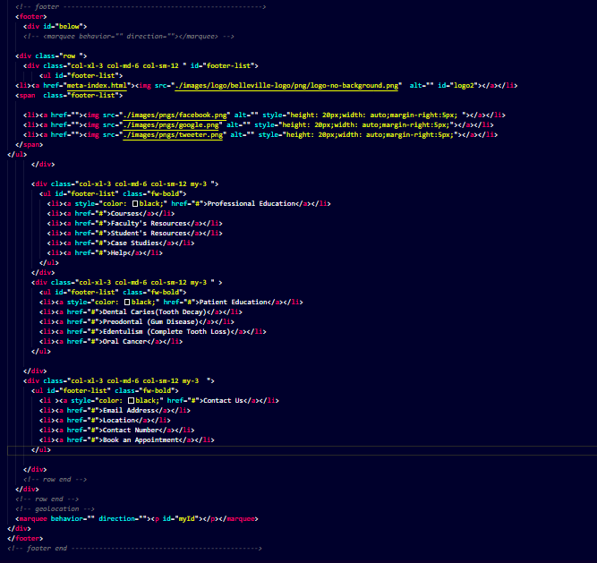

* **Footer CSS**

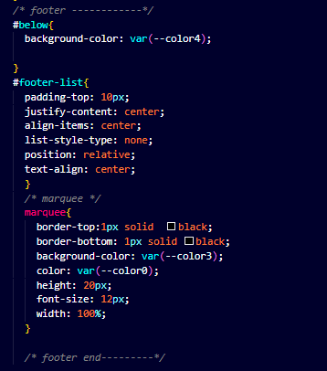

* **JavaScript files Links**

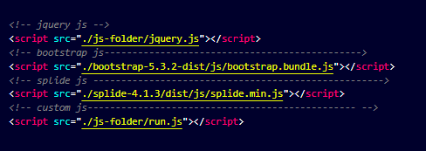

* **Current Date, Time, and Location:**
  + geolocation features of HTML5 to display the current location.



* 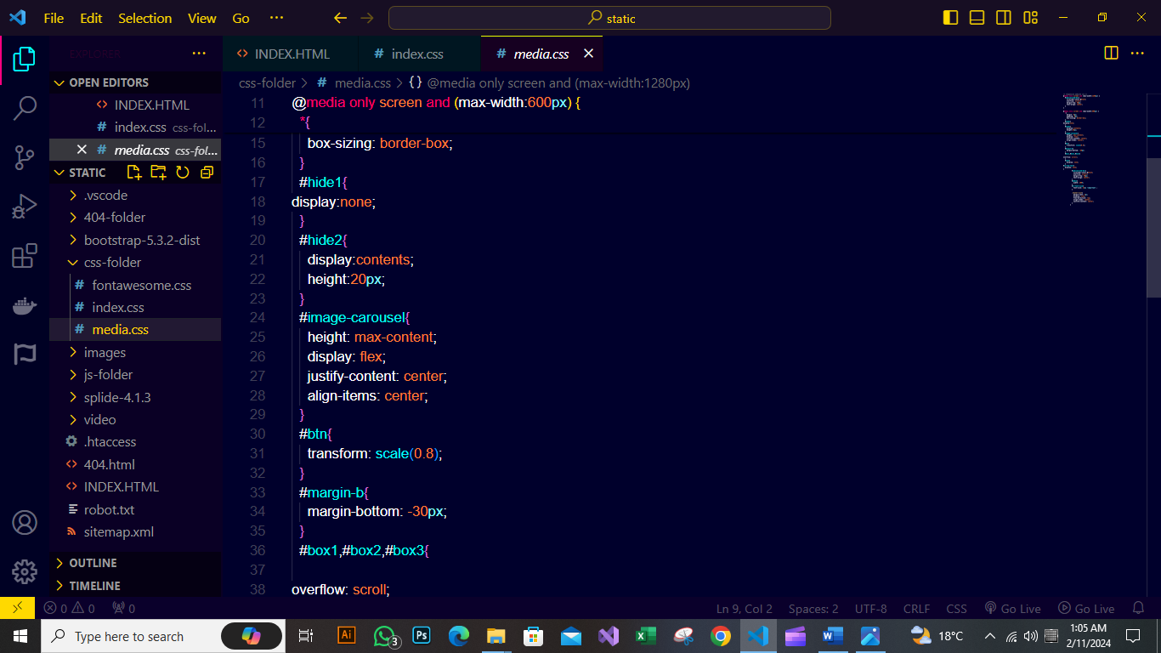**Responsive Css Coding**
* **run.js File**

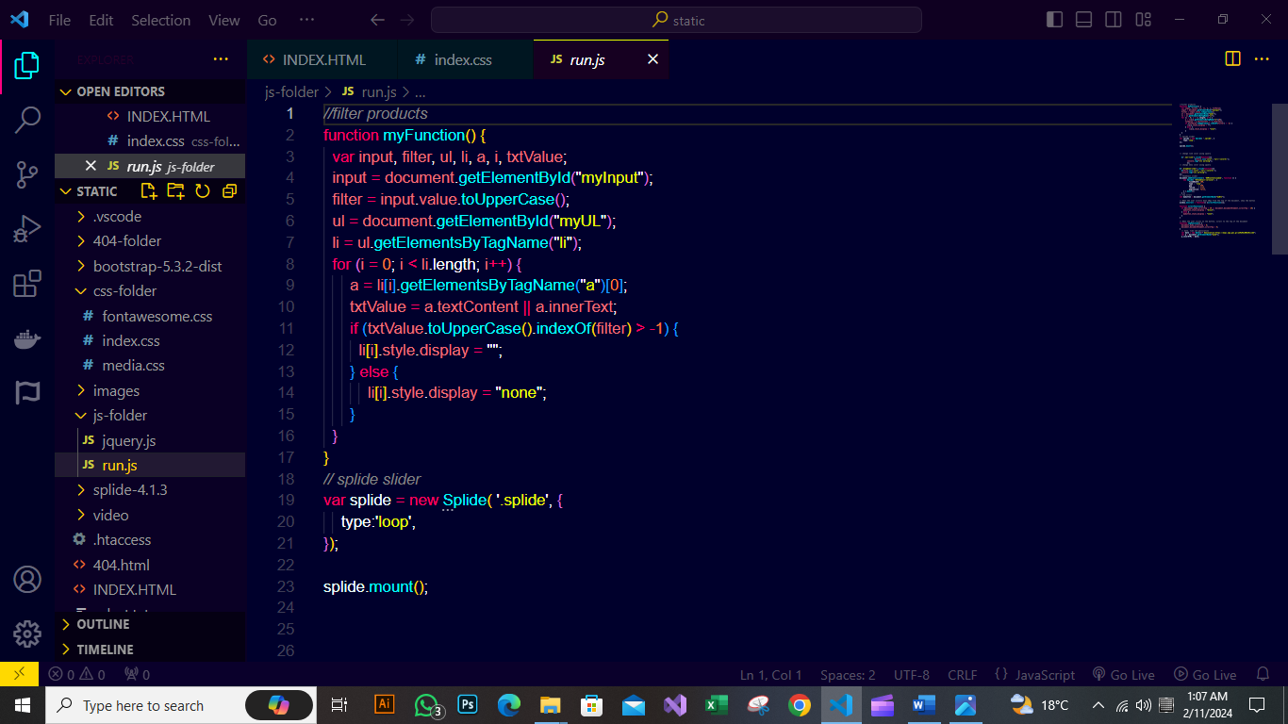

* **sitemap.xml File**

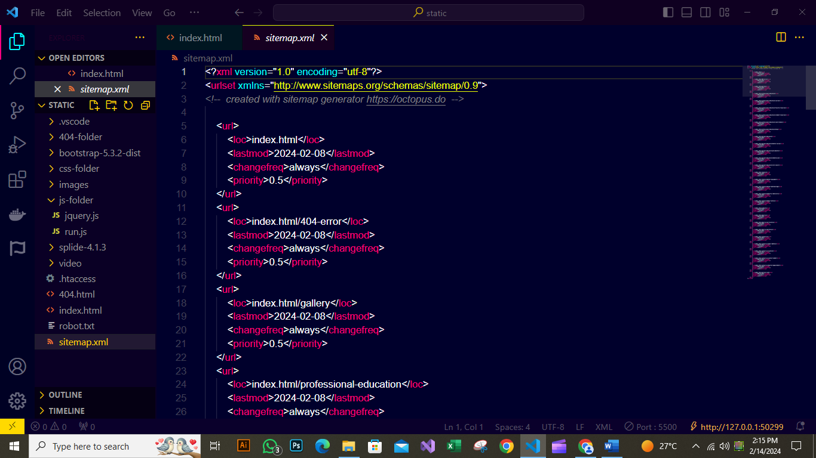

* 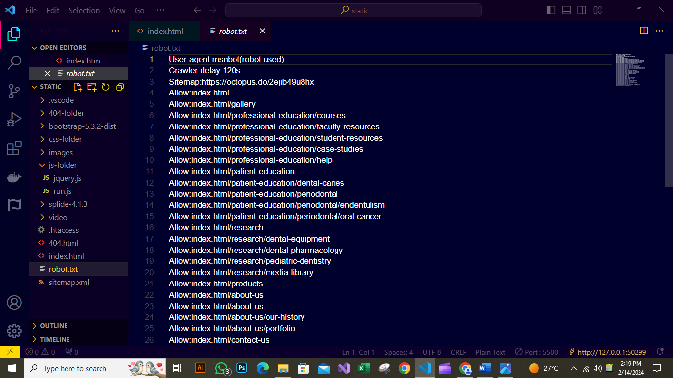**robot.txt File**

**Conclusion**

These technologies collectively contribute to the development of a dynamic, responsive, and feature-rich web application in the project. The developer guide likely provides details on how to leverage each technology effectively within the project context.

**Developed by:**

* **Zainab Iqbal**

Student ID:1522839

PR:PR0202309A

* **Hina Parween**

Student ID:1527915

PR:PR0202309A